1) **D** The tower is a 4 x 1 x 1 rectangular prism, which is four slabs. 4 slabs * 9 ore per slab = 36 ore.

2) **B** 

3) **E** The contrapositive will always be logically equivalent to the original statement, so IV is correct. III is also correct, as it is just a simple rewording of the original statement (NOT the converse)

4) **B** The sum of the exterior angles of a regular convex polygon will always be 360 degrees.

5) **B** 

6) **A** Given by definition

7) **B** One approach would be to first convert blocks to inches, and then calculate the area. 50 / 2.5 = 20, and 80 / 2.5 = 32.  
20 * 32 = 640

8) **C** Lateral surface area just means the surface area minus the bases. In this case, it is composed of three rectangles of length 3 and width 4. 3(3*4) = 36.

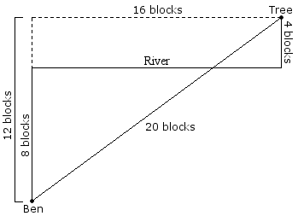9) **C** The shortest distance between two points is a straight line. So to solve this problem we can reflect the tree across the river so that our path from Ben to the Tree is a straight line, the length of which we can determine thanks to the sides of the newly formed right 12-16-20 right triangle.

10) **B** The platonic solids are the tetrahedron, hexahedron (or cube), octahedron, dodecahedron, and icosahedron.

11) **A** We want the volume of the sphere minus the volume of the cube. The volume of the sphere is . The volume of the cube is a bit trickier. One method is knowing that the big spatial diagonal of a cube is equal to . In this case, , so the volume of the cube is . Thus, the answer is A.

12) **A** A translation is a shift in position

13) **C**

14) **E** # of diagonals is given by .  


15) **D** An additional layer of blocks will make the cube 5x5x5. 5*5*5 = 125. Then subtract the volume of the cobblestone (3*3*3 = 27) to get 98 blocks.

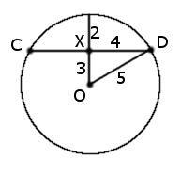16) **D** The key to this problem is knowing that the radius is 5. If we draw radius OD, we have a 3-4-5 right triangle. We find that OX has length 3, and therefore the distance from X to the edge of the circle is 2 (since the radius is 5, and 5 – 3 = 2).

17) **D** Jessie will walk along three sides, 1 block each, for a total of 3 blocks. For each corner of the triangle she will walk one third of a circle of radius 1 block. The distance for these is. Thus the total is  blocks.

18) **D**

19) **C** The measurement given is simply the tetrahedron’s slant height, which is also the height of one of the faces. Since all faces are equilateral we can easily find the side length to be . The area of the base is . Using right triangles in the *z* direction we find that the height of the pyramid is. Now we can find that the volume of the pyramid is then .

20) **B** She ends up 15 blocks north and 8 blocks east of her original position, forming an 8-15-17 right triangle.

21) **E** 180(*n* – 2) = 2880, *n* = 18. The measure of one exterior angle is 360° / 18 = 20°.

22) **B** We know that 180° = 12 hours = 720 minutes. We can divide by 180 to find that 1° = 4 minutes. Multiply by 136 to get 544 minutes. Divide by 60 to get 9 hours and 4 minutes. Add this to 6 AM to end up with 3:04 PM.

23) **D** Since all angles in a triangle add up to 180 degrees, we know that angle Z is 67 degrees. The measure of arc XY is twice the measure of angle Z, which is 2 * 67 = 134 degrees.

24) **C** This can easily be found by testing cases.

25) **C** The parabolic path is symmetric by nature, so the arrow will reach the maximum height of 15 at *x* = (3 + 11) / 2 = 7. Thus the point is (7, 15).